COURSE : DIGITAL SYSTEMS

DS LAB MINI-PROJECT
SEAT OCCUPANCY MONITORING SYSTEM.

Subhash S 111801042
K M Raswanth 111801056
P S Harikrishnan 111801028

Introduction 3
Description 3
Hardware 4
Software 4
Theory 5
- Combinational Logic
- Sequential Logic
- Finite State Machines
- Verilog
- Zynq Board
Approach 6
RTL Schematics
- Clock-division module 7
- Push-button debouncing 7
- Schematic of the entire project during demo 8
- Schematic of the project during simulation and testing 9
Conclusion 9
References 10
Links 10

Introduction
In this project we use Zynq board and Verilog to display the seat vacancies in buses with the help of combinational and sequential logic.

Description
It is critical to continuously monitor vehicle occupancy without creating privacy concerns. There is therefore the need for seat occupancy monitoring system to provide readily accessible seat occupancy information to passengers ensuring hassle free travel. In comparison to the current seat detection systems which use pressure sensors for seat vacancy detection we use push buttons as inputs.By making minor changes to this design we can use it in multiple purposes such as theatres and other vehicles. The current design displays the number of vacant seats at the top and bottom of a double decker bus. The idea of the project is to design a seat occupancy detection system in which there are two possible cases and they are explained below:
- An old person enters the bus:
If there are vacant seats in the bottom level then the old person chooses to sit at the bottom level of the bus else he moves to the top level in the bus and occupies a seat there.
- Anyone other than an old person enters the bus:
If there are vacant seats on the top level then that person chooses the top level else he moves to the bottom level.
The old person is given a preference to sit in the bottom level of the bus whereas others have to start by occupying the top level of the bus.
The reset state means that the bus has reached its destination and all the seats are vacant so it moves to a state of both_empty.

Hardware
- Zynq-Board. (Zybo)
- IC ULN-2003. (x2)
- Seven-segment display. (x2)
- Breadboard.
- Jumper wires.
- USB connector.
- Resistors (x14) (330Ω).

Software
- Xilinx Vivado

Theory

- Combinational Logic :
In digital circuit theory, combinational logic (sometimes also referred to as time-independent logic ) is a type of digital logic which is implemented by Boolean circuits where the output is a pure function of the present input only.
- Sequential Logic :
In digital circuit theory, sequential logic is a type of logic circuit whose output depends not only on the present value of its input signals but on the sequence of past inputs, the input history as well.
- Finite State Machines :
A finite state machine (sometimes called a finite state automaton) is a computation model that can be implemented with hardware or software and can be used to simulate sequential logic and some computer programs. Finite state automata generate regular languages. Finite state machines can be used to model problems in many fields including mathematics, artificial intelligence, games, and linguistics.
- Verilog :
Verilog is a Hardware Description Language; a textual format for describing electronic circuits and systems. Applied to electronic design, Verilog is intended to be used for verification through simulation, for timing analysis, for test analysis (testability analysis and fault grading) and for logic synthesis.
- Zynq-Board :
Zybo is a feature-rich, ready-to-use embedded software and digital circuit development board built around the Xilinx.

Approach

This problem is solved using both combinational and sequential logic. Finite State Machines (FSM) is used to keep track of the states of the two levels in a double-decker bus. A clock-divider is used to reduce the time period of the Zybo clock which is at 125 MHz to 4Hz for real-life human interactions. The inputs from the pushbuttons are debounced so that they are stable and are available for a single clock cycle irrespective of the time at which the buttons are triggered.
There are four states in this project
- up_full which represents the state when the top level is fully occupied and the bottom level is not fully occupied.
- down_full which represents the state when the bottom level is completely occupied and the top level is not completely occupied.
- both_full which represents the state where both the levels of the bus are completely occupied.
- both_empty which represents the state where both the top and bottom levels are not filled to their full capacity.
Two four-bit counters up and down are used which keep track of the number of empty seats in the bus and display it on a 7-segment display so as to show the number of vacant seats. The counters act as an up or down counter depending on the state and the inputs are given.
Initially the state is both_empty and then the state is decided according to the rules defined in the description of the project. If the state is both_full then there are no more changes until a person leaves the bus.

RTL-Schematic of different modules:
- Clock division module:

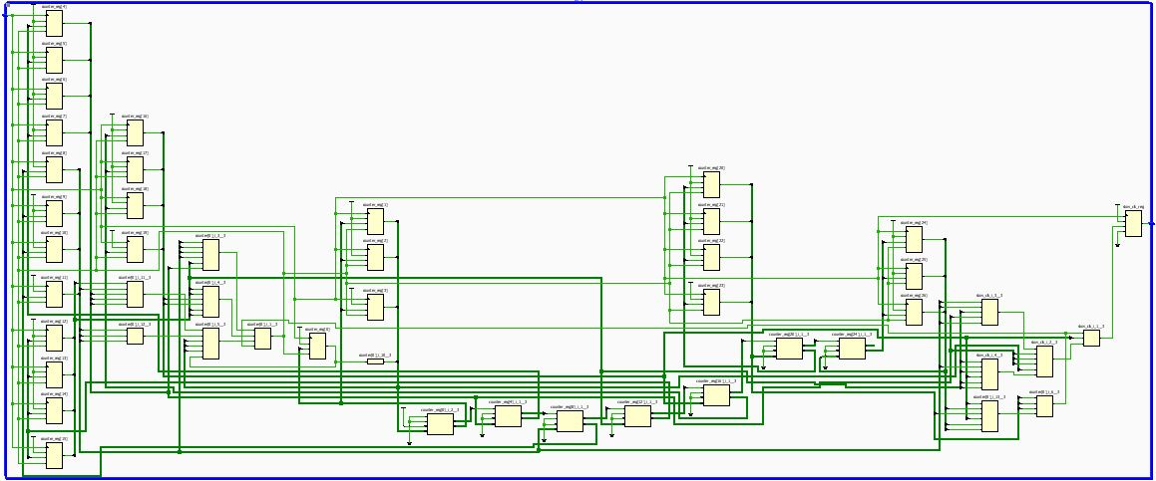

- Module for debouncing the push-button input:

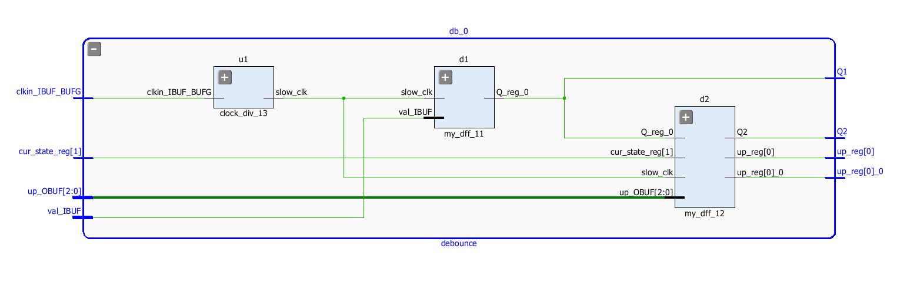
- Schematic of the complete module:

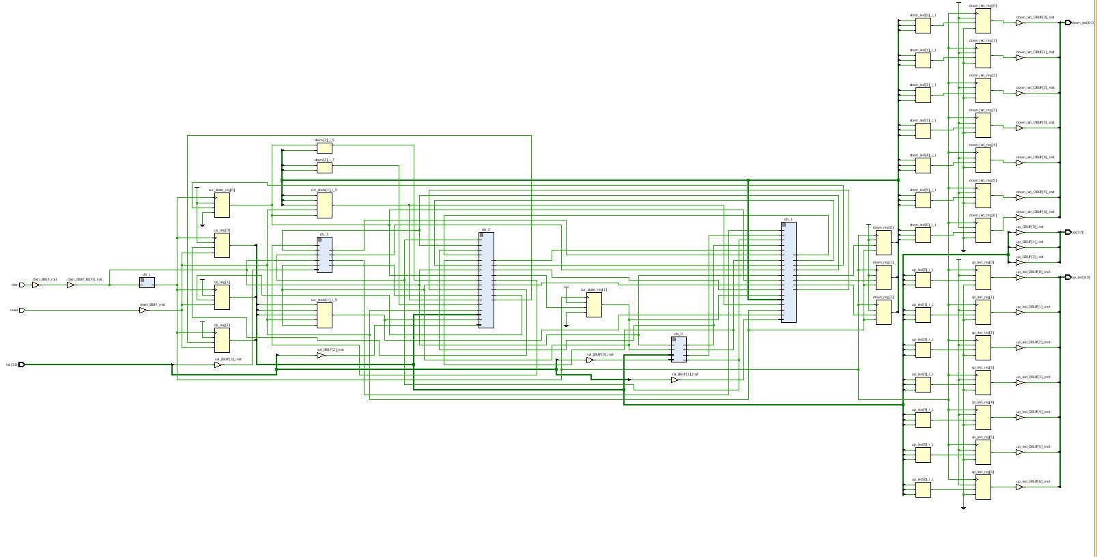

- Schematic of the complete project while simulation:

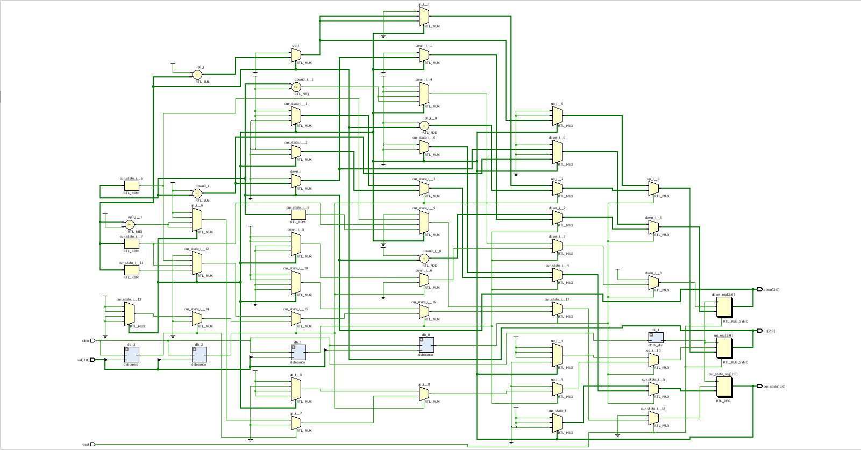

Conclusion
The project was made and displayed in the lab. We were able to implement all the features in the project that we thought would be feasible. Also connecting 2-dimensional matrix of LEDs on a breadboard would not have been feasible. The major challenge was debugging the HDL code. Accepting user input only when he presses input at the right time was the difficult task. The major challenge that we came across was running the simulation after debouncing the inputs as the simulation took a lot of time to get valid outputs as the scale of the simulation was in nanoseconds and the clock used in our project was in seconds(s) .

References
We didn’t require any additional references or help. We used the concepts learnt in the lab and in the course over the semester to implement our project.

Links
Link for videos, RTL schematics and other files related to project.

